DCC-GARCH correlation: EURUSD and USDCAD
Method 09 / GARCH(1,1) + Engle DCC / Alpari D1 full available history

Study setup
Logical pair: EURUSD , USDCAD
Broker symbols: EURUSD_i , USDCAD_i
Snapshot: 2026-11-03_majors_alpari_D1
Timeframe: D1
Matched return window: 1999-01-05 to 2026-11-02 (UTC bar dates)
Matched return count n: 7188
Dropped unfinished last bar dated 2026-11-03 UTC after a tick-volume check against the prior complete day.
EURUSD GARCH(1,1): mu=0.000008, omega=0.001158, alpha=0.036776, beta=0.959919
USDCAD GARCH(1,1): mu=-0.000007, omega=0.001261, alpha=0.043698, beta=0.951141
DCC: a=0.020367, b=0.976171, a+b=0.996537
Burn-in ignored in path summaries and chart: first 60 updates
Complete matched rows (Excel): EURUSD-USDCAD_DCC_D1.xlsx
Complete matched rows (HTML table): EURUSD-USDCAD_DCC_D1_data.html

Method carried forward
DCC-GARCH first fits a constant-mean GARCH(1,1) on each matched daily log return of close, ln(close_t / close_t-1), then updates Engle (2002) dynamic conditional correlation on the standardised shocks z = residual / conditional sigma. Quotes are not inverted. Correlation targeting sets Q_bar to the sample correlation of z; a and b are estimated by maximising the bivariate Gaussian DCC likelihood with a >= 0, b >= 0, and a + b < 1. Path summaries ignore the first 60 updates. The headline is rho on the last day. Same-sample Pearson r on log returns is a side check only. A high |rho| does not prove cause, lead-lag, or a trading signal.

Results
Latest DCC rho: -0.628887
Post-burn-in path (n=7128): mean=-0.424951, median=-0.456275, min=-0.727514, max=0.199969, std=0.177293
Share of post-burn-in days with |rho| >= 0.4: 60.49%; |rho| >= 0.7: 0.62%
Same-sample Pearson r: -0.456626
Latest rho minus r: -0.172262

Conclusion
Over 7188 matched daily log-return rows for EURUSD and USDCAD (broker quote directions unchanged), latest DCC rho is -0.6289 (negative, moderate conditional linear link in this sample) with fitted a=0.0204, b=0.9762 (a+b=0.9965). After a 60-day burn-in, path mean is -0.4250 and std is 0.1773. Same-sample Pearson r is -0.4566 (latest rho minus r = -0.1723). This does not establish cause, lead-lag, or a lasting trading rule.

Charts
Daily closes

Daily log returns
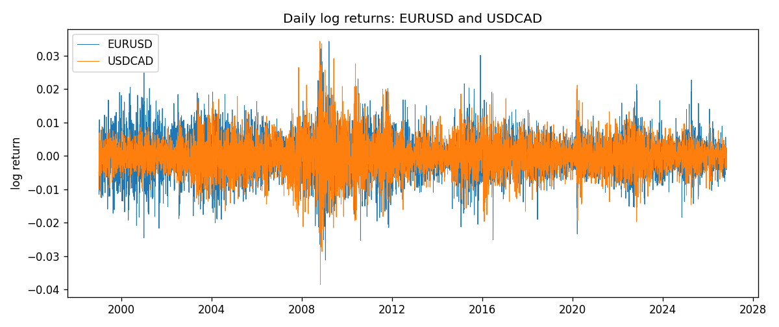
DCC rho path with Pearson r reference
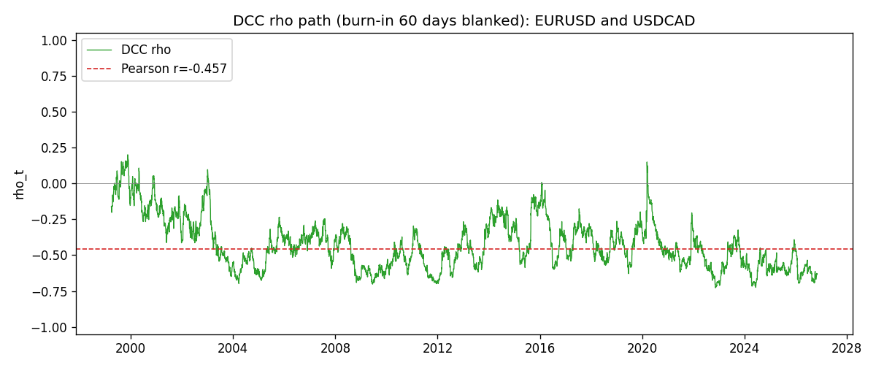

Data report
Every matched row that entered the DCC recursion is stored in the sibling Excel workbook named EURUSD-USDCAD_DCC_D1.xlsx. Embedding all rows as a Word table is impractical at this length; the Word file holds the column list, column summaries, and the first and last 15 matched rows.
Columns: time, EURUSD_open, USDCAD_open, EURUSD_high, USDCAD_high, EURUSD_low, USDCAD_low, EURUSD_close, USDCAD_close, EURUSD_tick_volume, USDCAD_tick_volume, EURUSD_spread, USDCAD_spread, EURUSD_real_volume, USDCAD_real_volume, EURUSD_log_return, USDCAD_log_return, EURUSD_sigma, USDCAD_sigma, EURUSD_z, USDCAD_z, q11, q22, q12, rho_t
Column summaries (matched calculation rows)
column | count | mean | std | min | 25% | 50% | 75% | max
EURUSD_open | 7188 | 1.1814345 | 0.15078289 | 0.8272 | 1.086195 | 1.16617 | 1.2939425 | 1.5995
USDCAD_open | 7188 | 1.2667783 | 0.16890181 | 0.9168 | 1.1183975 | 1.298465 | 1.37211 | 1.6183
EURUSD_high | 7188 | 1.1865652 | 0.15138546 | 0.8326 | 1.0902775 | 1.17128 | 1.2993025 | 1.6038
USDCAD_high | 7188 | 1.2716763 | 0.16885945 | 0.9336 | 1.12285 | 1.30387 | 1.37649 | 1.619
EURUSD_low | 7188 | 1.1764236 | 0.15010221 | 0.8227 | 1.0820675 | 1.16257 | 1.2883725 | 1.5865
USDCAD_low | 7188 | 1.26222 | 0.16893673 | 0.9056 | 1.114065 | 1.293535 | 1.367805 | 1.6102
EURUSD_close | 7188 | 1.181473 | 0.1507571 | 0.8267 | 1.0860725 | 1.166175 | 1.2939575 | 1.5997
USDCAD_close | 7188 | 1.2667932 | 0.16887388 | 0.916 | 1.118295 | 1.29844 | 1.372365 | 1.6137
EURUSD_tick_volume | 7188 | 103177.84 | 173518.96 | 218 | 9407.75 | 52764 | 99553.25 | 1471626
USDCAD_tick_volume | 7188 | 81016.727 | 147303.02 | 37 | 5545 | 40941.5 | 71627 | 1410818
EURUSD_spread | 7188 | 19.349471 | 16.556644 | 0 | 8 | 12 | 30 | 50
USDCAD_spread | 7188 | 23.444073 | 18.266035 | 0 | 9 | 17 | 40 | 60
EURUSD_real_volume | 7188 | 4.031926e+10 | 1.6689501e+11 | 0 | 0 | 0 | 0 | 3.6149665e+12
USDCAD_real_volume | 7188 | 1.8376704e+10 | 9.6688094e+10 | 0 | 0 | 0 | 0 | 2.5751613e+12
EURUSD_log_return | 7188 | -7.59e-06 | 0.00580128 | -0.03123819 | -0.0032472 | 0 | 0.00325412 | 0.03433183
USDCAD_log_return | 7188 | -1.518e-05 | 0.00514306 | -0.03859748 | -0.00283637 | 4.741e-05 | 0.00272353 | 0.03436319
EURUSD_sigma | 7188 | 0.00556718 | 0.00169853 | 0.00258113 | 0.00432465 | 0.00538034 | 0.00650004 | 0.0145923
USDCAD_sigma | 7188 | 0.00479354 | 0.00181431 | 0.00250987 | 0.00365307 | 0.00435879 | 0.00535078 | 0.01852804
EURUSD_z | 7188 | -0.00306762 | 1.0000308 | -5.7779382 | -0.62093401 | -0.0013085 | 0.60994165 | 5.208067
USDCAD_z | 7188 | 0.00136894 | 1.0000942 | -4.0706189 | -0.62969178 | 0.01079697 | 0.6114507 | 6.4148564
q11 | 7188 | 1.0009313 | 0.16152678 | 0.60746325 | 0.89032015 | 0.98804793 | 1.0948813 | 1.8473069
q22 | 7188 | 1.0012477 | 0.16059183 | 0.65183343 | 0.89838686 | 0.97830148 | 1.0746846 | 2.0451917
q12 | 7188 | -0.42415273 | 0.19784026 | -1.2028297 | -0.55353265 | -0.4377725 | -0.30278332 | 0.2304553
rho_t | 7188 | -0.42297848 | 0.17794658 | -0.72751398 | -0.56308739 | -0.45466608 | -0.31889544 | 0.19996935
First 15 matched rows (selected columns)
time | EURUSD_log_return | USDCAD_log_return | EURUSD_sigma | USDCAD_sigma | EURUSD_z | USDCAD_z | q11 | q22 | q12 | rho_t
1999-01-05 | -0.0048360507 | -0.010131666 | 0.0065775807 | 0.0045246099 | -0.73642735 | -2.2375938 | 1 | 1 | -0.42461909 | -0.42461909
1999-01-06 | -0.011547966 | -0.0003306769 | 0.0065199082 | 0.0049068243 | -1.7723909 | -0.065877717 | 0.99067874 | 1.0816053 | -0.38241052 | -0.36942732
1999-01-07 | 0.0076280636 | 0.0015202092 | 0.0067699454 | 0.0047990811 | 1.1255931 | 0.31831837 | 1.0345132 | 1.0593825 | -0.37239027 | -0.35571641
1999-01-08 | -0.010902799 | -0.0020495197 | 0.006800476 | 0.004704672 | -1.6043964 | -0.43405645 | 1.0391278 | 1.0396646 | -0.35768954 | -0.34413206
1999-01-11 | -0.007103287 | -0.0035137769 | 0.0069918943 | 0.0046217731 | -1.0170558 | -0.75865915 | 1.0702542 | 1.02219 | -0.33645315 | -0.32167353
1999-01-12 | 0.0045103728 | 0.0066194721 | 0.0069930458 | 0.0045804392 | 0.6438558 | 1.4467823 | 1.0692807 | 1.0130169 | -0.31419125 | -0.30188384
1999-01-13 | 0.010845346 | 0.0045420214 | 0.0069140434 | 0.0046904604 | 1.56746 | 0.96993632 | 1.0557062 | 1.034971 | -0.2892028 | -0.27667305
1999-01-14 | 0 | 0.0069376546 | 0.0070938817 | 0.0046857224 | -0.001107953 | 1.4821794 | 1.0840515 | 1.0329315 | -0.25281763 | -0.23891677
1999-01-15 | -0.010153245 | -0.0056905671 | 0.0069585911 | 0.0048080169 | -1.4602244 | -1.1820134 | 1.061682 | 1.0565226 | -0.24829696 | -0.23444166
1999-01-18 | 0.0036256946 | 0.00098344542 | 0.0070988768 | 0.004850254 | 0.50963483 | 0.20429279 | 1.0832723 | 1.0632644 | -0.20869779 | -0.19445916
1999-01-19 | -0.00017235436 | 0.002748513 | 0.0069979561 | 0.0047481075 | -0.025752383 | 0.58042904 | 1.0662112 | 1.0422403 | -0.20307458 | -0.19264157
1999-01-20 | -0.0031939256 | -0.0059646885 | 0.0068648085 | 0.004679848 | -0.46640563 | -1.2729606 | 1.0442804 | 1.0277286 | -0.20001025 | -0.19306541
1999-01-21 | 0.0030215416 | -0.0042823796 | 0.0067623659 | 0.0047442348 | 0.44565496 | -0.9010838 | 1.027289 | 1.0397039 | -0.18462255 | -0.17864201
1999-01-22 | -0.0012075213 | 0.0025057712 | 0.0066593203 | 0.0047257491 | -0.18250826 | 0.53180938 | 1.0103172 | 1.0349278 | -0.18987215 | -0.18568523
1999-01-25 | -0.0030251979 | 0.00085579808 | 0.0065375263 | 0.0046522699 | -0.46394575 | 0.18554912 | 0.99038315 | 1.0194891 | -0.18879476 | -0.18788713
Last 15 matched rows (selected columns)
time | EURUSD_log_return | USDCAD_log_return | EURUSD_sigma | USDCAD_sigma | EURUSD_z | USDCAD_z | q11 | q22 | q12 | rho_t
2026-10-13 | 0.0037402957 | -0.0046395653 | 0.0034547882 | 0.002887147 | 1.0803661 | -1.6044001 | 0.89505998 | 0.81806807 | -0.54948736 | -0.64215063
2026-10-14 | -0.0037582255 | 0.0015184751 | 0.003476397 | 0.0029986704 | -1.08333 | 0.50885939 | 0.90096574 | 0.85446239 | -0.57316596 | -0.65325053
2026-10-15 | 0.0056053107 | -0.0036101503 | 0.0034983405 | 0.0029631903 | 1.6000303 | -1.215826 | 0.90686138 | 0.84283758 | -0.57220547 | -0.65449993
2026-10-16 | 0.0017724895 | -0.0034322068 | 0.0036077605 | 0.0030074472 | 0.48912054 | -1.1387665 | 0.94085464 | 0.85632262 | -0.59966081 | -0.66807573
2026-10-19 | -0.0025394633 | -0.0018835331 | 0.0035671555 | 0.0030399713 | -0.71410483 | -0.61714615 | 0.92676995 | 0.86579095 | -0.5981857 | -0.66779557
2026-10-20 | 0.0023881672 | -0.0037066008 | 0.0035452861 | 0.0030116066 | 0.6714007 | -1.228306 | 0.91853425 | 0.8563795 | -0.57642599 | -0.64992425
2026-10-21 | -0.00032046717 | -0.00084691787 | 0.0035198688 | 0.0030578844 | -0.093278152 | -0.27453339 | 0.90928979 | 0.87016309 | -0.5809565 | -0.65311872
2026-10-22 | -0.0015949606 | -0.0026307268 | 0.0034659335 | 0.0030084312 | -0.46244981 | -0.87198281 | 0.891262 | 0.85442546 | -0.56806149 | -0.65096189
2026-10-23 | -0.001338521 | 2.85545e-05 | 0.0034265916 | 0.0030058669 | -0.39292128 | 0.011970262 | 0.87784218 | 0.85301365 | -0.54778253 | -0.63302661
2026-10-26 | -0.0022706559 | 5.7106554e-05 | 0.0033842901 | 0.0029529493 | -0.67326249 | 0.021853768 | 0.8635309 | 0.8361526 | -0.53629538 | -0.63113511
2026-10-27 | -0.004152342 | 0.0025379458 | 0.0033617136 | 0.0029017436 | -1.2375241 | 0.87718719 | 0.85564812 | 0.81970015 | -0.52528583 | -0.62722098
2026-10-28 | 0.0022262927 | -0.0038379274 | 0.0034059484 | 0.0029013618 | 0.65134076 | -1.3202424 | 0.86991207 | 0.81930122 | -0.5363477 | -0.63531183
2026-10-29 | 0.0022571351 | -0.00011436495 | 0.0033811762 | 0.0029620674 | 0.6652346 | -0.036102634 | 0.86128583 | 0.83874034 | -0.54255101 | -0.63834162
2026-10-30 | -0.0011458446 | -0.0010298736 | 0.0033579796 | 0.002910624 | -0.34357097 | -0.35128106 | 0.85323771 | 0.82224304 | -0.53158187 | -0.6346511
2026-11-02 | 0.002120569 | 0.00061519094 | 0.0033149449 | 0.0028687215 | 0.63732863 | 0.21703657 | 0.83877249 | 0.80862552 | -0.51792694 | -0.62888711

